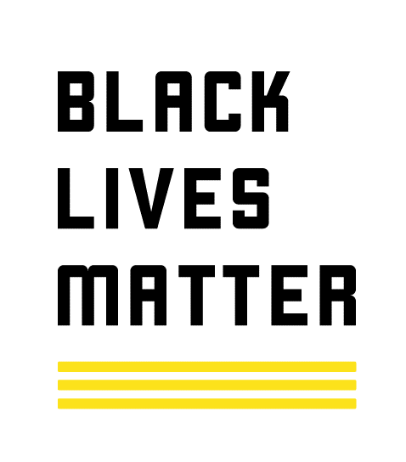
The Black Lives Matter Movement and Organization
Should Catholics Stand In Solidarity With Black Lives Matter?

Bernie Sammons, Ph.D., President and Founder Social Justice 4 All
Editor/Reviewer: Father Joseph Brown, SJ, Ph.D., Professor, Africana Studies Dept. Southern Illinois University, Carbondale, IL.

Date: August 13, 2020

Introduction
A Black Lives Matter Prayer vigil was held at Alphonsus Liguori “Rock” Catholic Church on June 27, 2020 in Saint Louis, MO. The vigil was sponsored by the Catholic Racial Justice Collaborative (CRJC), a multiracial group of Catholic lay and religious leaders in 14 parishes across St. Louis City, St. Louis County and St. Charles County to take action against racism, provide tools and resources for white Catholics to learn about racism and to uplift the voices of Catholics of color. The Archdiocesan Peace and Justice Commission co-sponsored the event.

The vigil was well received with support from many churches across the St. Louis region and drew approximately 350 people to the event. Many were energized and excited during and after the vigil wanting to do something that would put an end to racism that has been part of the American psyche for over 400 years. Many people of all ages and color were happy to shout loudly “Black Lives Matter” on that day. For many, the mantra, “Black Lives Matter”, was a call, first of all, for police reform after the murder of Mr. George Floyd that occurred in Minneapolis, MN on May 25, 2020. Video of the murder was viewed by many and fueled anger and shouts of “Black Lives Matter” globally. However, based on history, as with all effort to drive for social change, resistance or push back against change is a natural outcome. Managing or understanding why some would not fully support the Black Lives Matter movement after witnessing the murder of George Floyd is the purpose of this document.

On such a beautiful day where love and solidarity was expressed across color lines with people happy to shout “Black Lives Matter!”, how could a parishioner or anyone that views all life as sacred take exception to this slogan at this time? As part of the ceremony, the crowd stood in silence for 8 minutes and 46 seconds in honor of Mr. George Floyd, and the effect was stunning. How could the saying, “Black Lives Matter” upset anyone given the positive energy and shared love felt by all? It is my belief that it comes to down to a matter of messaging by the Black Lives Matter organization. It is common knowledge that the Black Lives Matter Movement is a central target of disinformation, so much so that people are asked to report suspicious sites, stories, ads, social accounts, and posts about BLM at the Black Lives Matter website (https://blacklivesmatter.com/about/).

In this paper, the messaging around Black Lives Matter will be discussed in the context of reconciling what BLM stands for as a mantra for the “Black Lives Matter” Movement and as a Global Organization. The movement and the organization are related but operate as distinct entities. This will then be viewed through of the lens understanding what it means to stand with a Black Lives Matter sign and how the movement can garner new allies in the face of the messaging and text that is reported at the Black Lives Matter website that is managed by the Global Foundation.

It is worth mentioning that another factor in the resistance or push back against the Black Lives Matter movement is driven by the fact that some do not agree that systemic racism and the differential treatment of people of color is a problem for our nation (Doorman, S. 2020). Some may ask, “Why talk about Black lives? Why not talk about all lives?” But to say “Black Lives Matter” is to say that “All Lives Matter,” including the lives of Black Americans that have been treated historically, and even today, as being expendable, disposable, and of little value (Hawkins, M. 2020). This statement speaks to the very purpose of this document.
Some hold the view that systemic racism in policing is not a problem and that un-armed white people are more likely to be killed by police than are people of color (Dorman, S. 2020). This view is in contradiction to a report from the Washington Post that states that Black Americans make up 13% of the population but are killed by police at more than twice the rate of white Americans (Stellino, M. 2020). In terms of people killed by police, more white people are killed by police annually in the U.S., but Black Americans are killed at a higher rate (Walters, J. 2020). The profiling of African Americans by police is well documented and three examples include:
- The 4.4 million stop and frisks that were conducted in New York City over the period from 2004 – 2012 where Blacks were disproportionately and illegally singled out (Bump, P. 2016)
- Status achieved in society is not barrier to racial profiling, as Republican African American senator Tim Scott has recounted multiple incidents where he was racially profiled by Capitol police (Somin, I. 2020)
- The documented racial profiling in Ferguson, Missouri points to the added risk of “driving while Black” for people of color (Strassmann, M. 2015).
If a reader is convinced that policing and the judicial system is fair and equitable for all people regardless of skin color, there is no argument presented here that will change their minds and hearts. This document is predicated on the belief that people of color are not treated the same as our white brothers and sisters in terms of fair policing. This belief is based on history, numerous studies, and the personal experience of many African Americans who were simply stopped by police for no apparent reason.

Background/History – Black Lives Matter
In 2013, three Black organizers — Alicia Garza, Patrisse Cullors, and Opal Tometi — created a Black-centered “political-will-and-movement-building” project called #BlackLivesMatter. It was in response to the acquittal of Trayvon Martin’s murderer, George Zimmerman. Black Lives Matter Foundation, Inc is a global organization in the US, UK, and Canada, whose mission is to eradicate white supremacy and build local power to intervene in violence inflicted on Black communities by the state and vigilantes. However, Black Lives Matter means a lot of different things to a lot of different people. It's a racial justice movement, a rallying cry, a social media hashtag and maybe even a political organization. For some, the movement is also a divisive force that has drawn a line between the police and the people and helped spawn some of the violence seen in the aftermath of high-profile, police-involved shootings. However, detractors and proponents of BLM have to admit that what started as a social media call for justice when George Zimmerman was acquitted of shooting and killing Trayvon Martin in Sanford, Florida has become a global force. The phrase “Black Lives Matter” is frequently employed to show opposition to police brutality as well as in connection with other racially charged issues. Used in this way, there are many people who say the phrase, “Black Lives Matter”, and it does not imply affiliation with a particular organization.

Organizational Structure of Black Lives Matter
The Black Lives Matter Movement and the Black Lives Matter Global Network Foundation are two distinct but related groups that represent the organizational structure of Black Lives Matter.

Black Lives Matter Movement
The Black Lives Matter Movement is a decentralized organization that consists of
14 affiliated chapters in the U.S and three in Canada. A map of affiliated chapters is shown below (https://blacklivesmatter.com/chapters/) and information for each chapter is reported in the Appendix. It is important to note that there are over 30 local chapters across the U.S. that are not affiliated with the global organization (Fraga, 2020). This fact is key to keep in mind in terms of the lack of consistent messaging from BLM activists, given that the movement is essentially a decentralized network with no hierarchy or leadership structure.

Black Lives Matter – Map of Affiliated Chapters

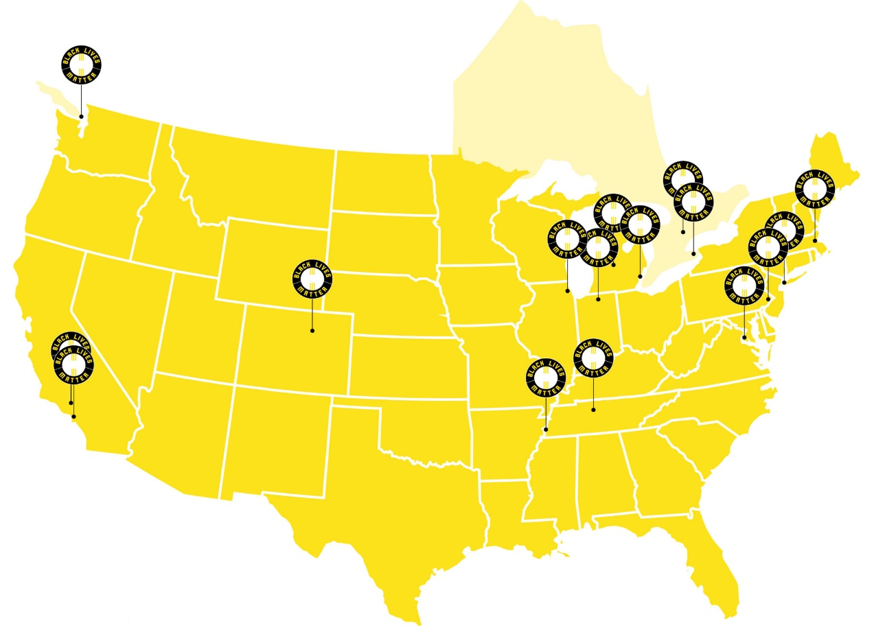

As a result of the decentralized structure, each chapter operates independently from all others with no organized common leadership or spokesperson that speaks for all chapters. In my effort to gather facts and official positioning from BLM to ensure accuracy on what the organization represents, I reached out to the three women who founded #BLM and the “Official” Black Lives Matter Chapter” in Memphis. I never received a response from any of the founders. The BLM Chapter in Memphis sent the following text: “There is a movement, a network, and organization. We are part of the movement and a charitable organization with a fiscal sponsor and registered agent”. When I reached out for more detail, no response from the Memphis Chapter was received. Based on information from the BLM website, anyone can start the process to form a chapter. Just how the movement should carry out the work of defending Black lives sometimes depends on whom you talk to. BLM's decentralized structure urges supporters to set up their own local chapters under the movement's flag; however, the group's grassroots founders Patrisse Cullors, Alicia Garza and Opal Tometi serve as figureheads and organizers but largely appear to let local chapters do their own thing.

Black Lives Matter – Messaging From Website (BLM Website)
At its core, the Black Lives Matter Movement is focused on eradicating white supremacy and to intervene in violence inflicted on Black communities by the state and vigilantes. Recall that the genesis of BLM was in response to the acquittal of Trayvon Martin’s murderer and that focus carries through to the present. After witnessing the video of the horrific murder of George Floyd, it was easy for many to become energized and protest as allies with BLM. However, a review of the BLM website will reveal messaging that can be interpreted as problematic or in conflict with several teachings of the Catholic Church. Long before the murder of George Floyd, “Black Lives Matter” was already a polarizing statement in a country with deep racial fault lines (Fraga, B. 2020). The conflict arises from some associating the phrase with the organization Black Lives Matter Global Network Foundation, Inc., which holds views that oppose Church teaching, while others associate it only with the movement to raise awareness of police and vigilante brutality against people of color. For this reason, there are ample publications written in support of and against BLM by clergy of the Church.

Black Lives Global Network Foundation
Black Lives Matter Global Network Foundation is probably the central Black Lives Matter organization. It claims Garza, Cullors, and Tometi as co-founders and operates the BlackLivesMatter.com website. It has been a fiscally sponsored project of Thousand Currents, a 501(c)(3) nonprofit since 2016. As a 501(c)(3) sponsored project, this allows for tax-deductible donations. Thousand Currents is a grantmaking organization that provides financial assistance to left-leaning projects and organizations and activists in developing nations (Thousand Currents). In 2016, representatives of the Black Lives Matter (BLM) movement approached Thousand Currents for fiscal management and administrative assistance. This partnership led to a fiscal sponsorship agreement that launched the Black Lives Matter Global Network Foundation. The Black Lives Global Network Foundation and the Black Lives Matter Movement are distinct organizations with independent revenue streams but partner in messaging at the Black Lives Matter website.

Argument Against Standing With BLM – Global Network Foundation, Inc.
A review of information provided at the BLM – Global Network Foundation website will provide positioning that will both contradict and support the teaching of the Catholic Church (https://blacklivesmatter.com/what-we-believe/). An example of language that some in the Catholic Church have a negative reaction to is the statement that fellow activists are referred to as “comrades” on the website (a term that some view as “communist”), and the statement from one of the founders, Patrisse Cullors, where she states that she is a trained Marxist (Steinbuch, Y. 2020). This has led some to conclude the BLM is a communist organization that is anti-government. However, as stated many times in this document, the chapters and individual activists are free to operate as they choose without declaring themselves as Marxists or as proponents of any specific ideology. Believing in Marxist ideology is not a requirement to form a chapter or to participate as a BLM activist.

Additional language regarding structure of the family and sexual orientation found on the Global Network website leads some to reject support for BLM. The following excerpts are sourced from the BLM website, “What We Believe”:
- “We disrupt the Western-prescribed nuclear family structure requirement by supporting each other as extended families and “villages” that collectively care for one another”…..
- Patrisse Cullors, one of the co-founders of BLM describes herself as “queer” and the group seeks to “dismantle cisgender privilege and uplift Black trans folk,” as well as to “foster a queer‐affirming network.….” (Clark. 2020)
- Alicia Garza, another co-founder of BLM that is also self-described as queer, goes on to say her “ leadership and work challenges the misconception that only cisgender Black men encounter police and state violence. While the tragic deaths of Trayvon Martin and Mike Brown were catalysts for the emergence of the BLM Movement, Garza is clear: In order to truly understand how devastating and widespread this type of violence is in Black America, we must view this epidemic through a lens of race, gender, sexual orientation, and gender identity” (https://blacklivesmatter.com/our-co-founders/).

The positions taken above on disrupting the nuclear family and support for the queer community are clearly not supported by teachings of the Church. However, we must remember that BLM was not founded a religious organization, and as such, cannot be expected to completely align with all Catholic beliefs. Again, to repeat the decentralized structure of the BLM Movement covering over 30 chapters across the U.S., there is no requirement for training or adoption of any of the positions of the original co-founders reported here. It is not surprising that since two of the co-founders identify themselves as queer, they would envision an organization that affirms the LGBTQ community. I would offer that the statement on disrupting the nuclear family is written to affirm the many single parent households in the African American community and the unalterable reality of the impossibility of there being a “nuclear family” because of the deliberate, economically motivated destruction of the Black family. Destruction of the Black family dates back to the capture and enslavement of Black people to the present practices of the policing and incarceration strategies employed in the Black, Brown, and Native cultures. Black Lives Matter declares that it exists to end violence against all Black people regardless of sexual orientation or family structure.

If seeing the video of the murder of George Floyd (and many, many other victims not mentioned here) moves you to act, the Black Lives Matter Movement offers a vehicle for civil disobedience, but only if you can reconcile the philosophy of individual members with the overall banner that demands fair policing and an end to acts of violence by vigilantes. Driving social change is hard, and experience over many generations has taught us that pushing for change will always be met with resistance. It is easier for some to do nothing than to work through what it means to stand with Black Lives Matter given the lack of consistent messaging for the movement. For people who are looking for an “off ramp” which allows them to take no action for whatever reason, then the status quo is maintained. Unfortunately for some, maintaining the status quo is the goal. As Christians, we are called to put our faith into action which means if the BLM Movement is not the vehicle for action, then we need to offer our full attention and spiritual energy into finding a solution that will deliver equal justice for all regardless of skin color.

Arguments For Standing With BLM - Movement
A review of the Black Lives Matter website will reveal a list of many goals the majority of which people will like, such as: (BLM website, What We Believe)
- “We work vigorously for freedom and justice for Black people and, by extension, all people.”
- “We acknowledge, respect, and celebrate differences and commonalities.”
- “To love and desire freedom and justice for ourselves is a prerequisite for wanting the same for others.”
- “We make our spaces family-friendly and enable parents to fully participate with their children…..”

All goals listed above are compatible with teaching from the Catholic Church. Furthermore, some who reject Black Lives Matter state that BLM is anti-police, but the statement from the website affirms freedom and justice for all people regardless of skin color or occupation. Again, chapters in the Black Lives Matter Movement are not bound to agree with or comply with goals listed on the Global Foundation website. With that as a given, then what does it mean to stand with the Black Lives Matter movement? Can, or should Catholics support the Black Lives Matter movement while still honoring the core values and teaching of the Church? An argument will be made here that the answer is yes for many reasons.

Using Catholic Social Teaching
There is common ground between a subset of the goals listed on the BLM website and the Seven Themes of Catholic Social Teaching published by the U.S. Conference of Catholic Bishops (United States Conference of Catholic Bishops, 2020). In particular, the call from Black Lives Matter and Catholic Social Teaching to honor and respect the Life and Dignity of the Human Person and the call to stand in Solidarity that commands respect for people of different cultures and color are highlights as reasons to support the Black Lives Matter Movement. Based on how and why Black Lives Matter was formed, proponents and opponents of the BLM movement have mischaracterized what the slogan “Black Lives Matter” means (Fraga, 2020). If we as Catholics were to approach this from a Catholic Social Teaching perspective and an open mind, we would perceive Black Lives Matter very differently than the messaging heard in the media and from some political leaders. The original purpose and focus of Black Lives Matter was to call for justice for all Black people and to demand an end to the long litany of Black Lives lost at the hands of vigilantes or from police brutality. This is a message that all Catholics, Christians, people of all faiths, or no faith at all can support if simply for no other reason than to say that all life is precious and should be honored. Although BLM is an imperfect organization in terms of what some would call its central messaging or some of its objectives and goals, the Black Lives Matter Movement does provide a vehicle for people to protest and work toward a more just world for all of God’s people. This appeal to honor all lives is why the Back Lives Matter Movement has garnered global support.

A Call To Action: We are called to put our faith into action and many are familiar with the common bible passage that states that “faith without works is dead” (James 2:14-26). The murder of George Floyd provides an inflection point for Black Lives Matter and provides an opportunity to onboard new allies that may have stood on the sidelines in the past. The video of Mr. Floyd’s death has sparked global interest in Black Lives Matter at a level never seen before. To hear someone say that they are “not racist” is no longer sufficient if we really want to achieve real and lasting change. People need to move to a position of being “anti-racist” which calls for action on our part to end racism and white supremacy. A link to a YouTube video that explains the difference between a “not racist” position vs. “anti-racist” is provided here (James, M. 2020. YouTube.
https://www.youtube.com/watch?v=jm5DWa2bpbs). If/when another atrocity happens at the hands of police or vigilantes, and assuming that there is video of the incident as was the case with George Floyd, what will you do? If you are moved to action, how will that emotion be expressed? If/when another tragedy does happen, it is a given that protestors representing the Black Lives Matter Movement will stand up and demand justice. If you do not stand with them, what will you do? Although some of the messaging offered by the Global Foundation is judged to not be compatible with Church teaching, there is much that the Black Lives Matter Movement and Catholic Social Teaching have in common. At its basic level, we are called to respect all lives, regardless of race or socioeconomic status. This basic requirement is compatible with both the BLM Movement and the Catholic Church. Father Matthew Hawkins (Catholic Voices On Racism, 2020) says that “The cry, “Black Lives Matter” is not a new cry that suddenly emerged in the past 10 years. It is a cry that is at least 400 years old and has spanned many different stages of American history” (Hawkins, M. 2020). The mantra Black Lives Matter means many different things to different people, but it is grounded in reality, in a specific and concrete history, and in contemporary social experiences. These should not be misinterpreted or misunderstood.

For centuries, African American lives have been treated as though they did not matter. They were treated as though they were cheap and expendable. This was true under the regime of chattel slavery; it was true during the mass lynching of Blacks in the post-civil war South, and in riots in the North to prevent racial integration. It was true for 100 years after emancipation and it was true when Black soldiers were sent to the front lines of the battlefields to absorb the brunt of the casualties in times of war. It has also been true under more recent policies of mass incarceration and disproportionate sentencing to capital punishment (Hawkins, M. 2020). With this as our history, for Catholics and our brothers and sisters around the globe who are moved to take action to create a more just world, how can we best stand in solidarity with our brothers and sisters of color? The Black Lives Matter Movement offers a vehicle for people to rally around the call for justice as one community. There is common ground for people to stand as one human family while recognizing there are differences between BLM and some of the teachings of the Catholic Church. At its core, Black Lives Matter affirms the dignity of all lives and that life is sacred. If becoming anti-racist is the goal, then Catholics can stand with the BLM Movement and affirm:
- We affirm all lives, regardless of skin color. The movement calls for freedom and justice for all people.
- This movement is not anti-police. The demand is for fair policing.
- We affirm that BLM Movement advocates for non-violent civil disobedience against all racially motivated violence.
- This movement is not Black vs. White. This movement requires Black, White, and Brown people globally to join in the fight to end racism together, as one human family.
The decision to stand with the Black Lives Matter Movement as an informed participant does require reflection and prayer on what the chant “Black Lives Matter” means to you personally and for the movement at large. The loose, unstructured organization of Black Lives Matter certainly adds to the complexity of what it means to stand with the Black Lives Matter Movement, but at its core, the mission of the movement is to save lives. All Catholics, Christians, and otherwise should find solace in standing for and supporting a movement that serves as a watchdog globally with the goal of preserving lives for all, regardless of skin color or socioeconomic standing. Lastly, for Catholics seeking another option to take action in support of the Black Lives Matter Movement, there is a group specifically for Catholics called “Catholics United For Black Lives” (https://www.facebook.com/groups/213070479939516). This group was formed by devout Catholics seeking to unite as one Body of Christ in the fight for Black Lives. As stated many times in this document, chapters are not bound to honor any particular ideology of belief system other than affirming the sanctity and dignity of all lives. In conclusion, there is ample space for anyone wanting to put an end to violence by vigilantes and police brutality against Black people to engage with the Black Lives Matter Movement, or if preferred, people can form their own chapter as the Catholic group did in their effort to drive for social change.

References
About Black Lives Matter <<https://blacklivesmatter.com/about/>>

Black Lives Matter. Our Co-Founders. https://blacklivesmatter.com/our-co-founders/

Black Lives Matter. How To Become A Chapter
https://blacklivesmatter.com/how-to-become-a-chapter/

Bump, P. September 26, 2016. The facts about stop-and-frisk in New York City. The Washington Post.
https://www.washingtonpost.com/news/the-fix/wp/2016/09/21/it-looks-like-rudy- giuliani-convinced-donald-trump-that-stop-and-f

Catholics United For Black Lives. July 15, 2020. https://www.facebook.com/groups/213070479939516

Clark, H. June 22, 2020. Christian News. https://christiannews.net/2020/06/22/queer-black-lives-matter-co-founder-we-are-trained-marxists-effort-includes-fighting-for-transgenders-homosexuals/

Dorman, Sam. July 28, 2020. Fox News. Barr says he doesn’t believe there’s systemic racism in US policing. https://www.foxnews.com/politics/william-barr-systemic-racism-policing-united-states

Fraga, Brian. July 13, 2020. Our Sunday Visitor. Can Catholics Support Black Lives Matter? <https://www.osvnews.com/2020/07/13/can-catholics-support-black-lives-matter>

“FAQs.” Thousand Currents. Accessed May 25, 2020.
https://thousandcurrents.org/faqs/ ^

Hawkins, Matthew. June 30, 2020. Toward a Catholic Understanding of the Phrase “Black Lives Matter”. Catholic Voices On Racism. <<https://diopitt.org/news/toward-a-catholic-understanding-of-the-phrase-black-lives-matter?fbclid=IwAR2VjYn-kSVpC4KaU6zL0hAHZyHiVvWbKtHTZ06M_x1Gr_UY7I21LD7mztM

History/Founding of Black Lives Matter <<https://blacklivesmatter.com/herstory/>>

James, Marlon. Jan. 13, 2016. Are you racist? “No” isn’t a good enough answer.
https://www.youtube.com/watch?v=jm5DWa2bpbs

Opfer, Chris. August 1, 2016. How Is The Black Lives Matter Movement Organized?
https://people.howstuffworks.com/black-lives-matter-movement-organization-structure.htm

Somin, Ilya. The Volokh Conspiracy. June 8, 2020. Police. The Problem of Racial Profiling – Why it Matters and What Can be Done About it.
https://reason.com/2020/06/08/the-problem-of-racial-profiling-why-it-matters-and-what-can- be-done-about-it/

Strassmann, Mark. March 3, 2015. CBS News. DOJ findings on racial profiling all too familiar in Ferguson. https://www.cbsnews.com/news/justice-department-findings-on-racial-profiling-all- too-familiar-in-ferguson/

Steinbuch, Yaron. June 25, 2020. NY Post. Black Lives Matter co-founder describes herself as ‘trained Marxist’. https://nypost.com/2020/06/25/blm-co-founder-describes-herself-as-trained marxist/

Stellino, Molly. June 23, 2020. Fact Check: Police killed more unarmed Black men in 2019 than conservative activist claimed.
https://www.usatoday.com/story/news/factcheck/2020/06/23/fact-check-how-many unarmed-black-men-did-police-kill-2019/5322455002/

Stilson, Robert. June 18, 2020. The Organizational Structure of Black Lives Matter.
https://capitalresearch.org/article/the-organizational-structure-of-black-lives-matter/

Thousand Currents and Black Lives Matter. https://thousandcurrents.org/black-lives-matter/

Unites States Council of Catholic Bishops. 2020. Seven Themes of Catholic Social Teaching.
https://www.usccb.org/beliefs-and-teachings/what-we-believe/catholic-social-teaching/seven-themes-of-catholic-social-teaching

Walters, Joanna. July 14, 2020. The Guardian. Trump twists stats on police brutality: “more white people” are killed. https://www.theguardian.com/us-news/2020/jul/14/donald-trump-george-floyd-police-killings

What We Believe. Black Lives Matter Website. https://blacklivesmatter.com/what-we-believe/

appendix

Black Lives Matter – List of Affiliated Chapters

United States

Boston
Boston, Massachusetts
Ways to Connect:
Email – boston@blacklivesmatter.com
Website – BlackLivesMatterBoston.org
Facebook – facebook.com/BLMBoston
Twitter – twitter.com/BLMBoston

Chicago
Chicago, Illinois
Ways to Connect:
Website – BlackLivesMatterChicago.com
Facebook – facebook.com/BLMChi
Instagram – instagram.com/BLMChi
Twitter – twitter.com/BLMChi

DC
Washington, District of Columbia
Ways to Connect:
Email – info@dcblm.org
Website – BlackLivesMatterDMV.org
Facebook – facebook.com/BLMDC
Instagram – instagram.com/BlackLivesMatterDC
Twitter – twitter.com/DMVBlackLives

Denver
Denver, Colorado
Ways to Connect:
Email – blacklivesmatter5280@gmail.com
Website – BlackLivesMatter5280.WordPress.com
Facebook – facebook.com/BlackLivesMatter5280
Instagram – instagram.com/BLM5280
Twitter – twitter.com/BLM5280

Detroit
Detroit, Michigan
Ways to Connect:
Email – leadership@blmdetroit.com
Website – BLMDetroit.com
Facebook – facebook.com/DetroitBLM
Twitter – twitter.com/DetroitBLM

LA
Los Angeles, California
Ways to Connect:
Email – emailblmla@gmail.com
Website – BLMLA.org
Facebook – facebook.com/BLMLA
Instagram – instagram.com/BLMLosAngeles
Twitter – twitter.com/BLMLA

Lansing
Lansing, Michigan
Ways to Connect:
Website – liberationpac.org/BLMLansing
Facebook – facebook.com/BLMLansing
Twitter – twitter.com/BLMLansing

Long Beach
Long Beach, California
Ways to Connect:
Email – lbcblacklivesmatter@gmail.com
Website – blmlbc.org
Facebook – facebook.com/Groups/BlackLivesMatterLBC
Instagram – instagram.com/BLMLBC
Twitter – twitter.com/BLMLBC

Official Black Lives Matter Memphis Chapter
Memphis, Tennessee
Ways to Connect:
Email – BlackLivesMatterMemphis@Gmail.com
Facebook – facebook.com/BLMMemphis
Twitter – twitter.com/BLM_Memphis

Michigan
State of Michigan
Ways to Connect:
Facebook – facebook.com/BLMMichigan
Instagram – instagram.com/blmmichigan
Twitter – twitter.com/BLMMichigan

Nashville
Nashville, Tennessee
Ways to Connect:
Website – BlackLivesMatterNashville.WordPress.com
Facebook – facebook.com/BlackLivesMatterNashville
Instagram – instagram.com/BLM_Nashville
Twitter – twitter.com/BLM_Nashville

NYC
New York, New York
Ways to Connect:
Facebook – facebook.com/BlackLivesMatter
Instagram – instagram.com/BLMNYC
Twitter – twitter.com/BLMNYC

Philly
Philadelphia, Pennsylvania
Ways to Connect:
Email – BlackLivesMatterPhilly@Gmail.com
Website – BLMPhilly.com
Facebook – facebook.com/BlackLivesMatterPhilly
Instagram – instagram.com/BLMPhilly
Twitter – twitter.com/BLMPhilly

South Bend
South Bend, Indiana
Ways to Connect:
Email – blm.southbend@gmail.com
Website – BlackLivesSouthBend.com
Facebook – facebook.com/BlackLMSouthBend
Twitter – twitter.com/BLMSouthBend

Canada

Toronto

Toronto, Ontario
Ways to Connect:
Email – info@blacklivesmatter.ca
Website – blacklivesmatter.ca
Facebook – facebook.com/BlackLivesMatterTO
Twitter – twitter.com/BLM_TO

Vancouver
Vancouver, British Columbia
Ways to Connect:
Website – blacklivesmattervancouver.com
Facebook – facebook.com/BlackLivesMatterVancouver
Instagram – instagram.com/BLM_Van
Twitter – twitter.com/BLM_Van

Waterloo
Waterloo, Ontario
Ways to Connect:
Facebook – facebook.com/BlackLivesMatterWaterlooRegion

